WEEK-6
GIT
- Git Configuration and Version Control
The primary objective of this hands-on lab was to become familiar with fundamental Git version control operations.
Key Requirements:
- Understand and execute standard Git commands (git init, git status, git add, git commit, git push, and git pull).
- Configure local Git user credentials (Name and Email).
- Integrate a text editor (originally specified as Notepad++) to handle multi-line commit messages.
- Initialize a local repository named GitDemo.
- Create a file named welcome.txt, add content, and track it via the local repository.
- Create a remote repository on GitLab (without using corporate credentials) and push the local codebase to the remote server.
Instead of utilizing standard Git Bash and configuring Notepad++ globally, we executed the lab using IntelliJ IDEA 2026.1.3 and its integrated terminal. This provided a modernized, streamlined development workflow while still fulfilling all underlying command-line objectives.
Step 1: Project Creation and Git Initialization
- Created a new Empty Project in IntelliJ IDEA named GitDemo.
- Selected the Create Git repository option during the setup wizard. This automatically ran git init in the background, initializing the hidden .git tracking folder.
Step 2: User Configuration
Opened the IntelliJ built-in terminal (Alt + F12) to configure the local Git environment:
- Executed git config --global user.name "Your Name"
- Executed git config --global user.email "your.email@example.com"
- Verified the setup using git config --global --list.
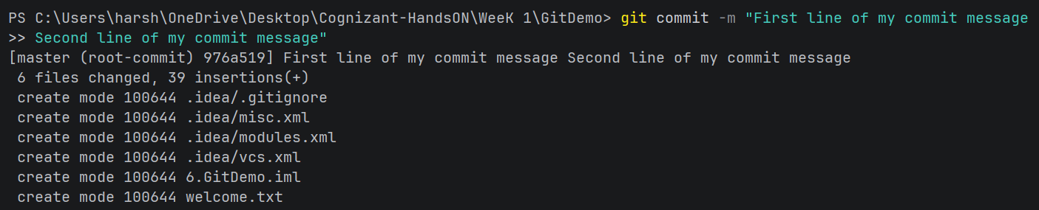
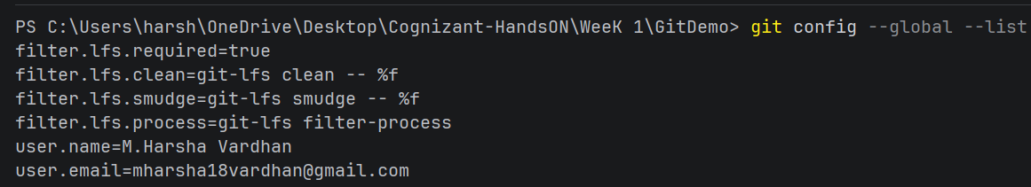
- Git Remote Configuration & Push Resolution
- Issue: When attempting to push local changes to a remote Git repository via the IDE interface (JetBrains / IntelliJ / PyCharm), the interface displayed "No commits selected", and the Push button remained disabled.
- Goal: Understand why there was nothing to push, set up the required configurations, and successfully push local code to the remote repository.
2. Cause Analysis
Two underlying issues were identified from the Git Push window:
- Unconfigured Remote Repository: The branch source read master -> Define remote, indicating that no remote destination (e.g., GitHub, GitLab, Bitbucket) was mapped to the local repository.
- Uncommitted Local Changes: There were no staged/committed snapshots on the local master branch ready to be transmitted.
Step 1: Defined the Remote Repository
- Clicked Define remote in the top-left section of the Push window.
- Added the target remote repository URL (e.g., [https://github.com/username/repository.git](https://github.com/username/repository.git)) and assigned it to the default remote identifier (origin).
Step 2: Staged and Committed Local Changes
- Opened the local Commit tool window (Alt + 0 / Cmd + 0).
- Selected all modified project files.
- Entered a descriptive commit message.
- Performed a local Commit.
Step 3: Pushed Code to Remote
- Re-opened the Push dialog (Ctrl + Shift + K / Cmd + Shift + K).
- Confirmed that the newly created commits appeared under the target branch (master -> origin/master).
- Executed Push to sync local changes with the remote repository.
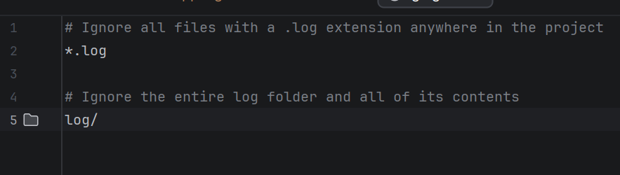
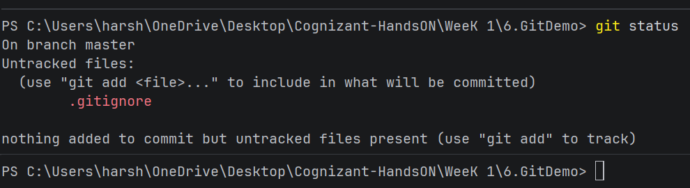

- Multi-Agent AI System Architect
1. Executive Summary
This project delivers an automated AI System Architect powered by a multi-agent orchestration framework. The system accepts high-level software requirements from a user and automatically generates comprehensive architecture blueprints, interactive diagrams, JSON schemas, and initial project scaffold code through an iterative agent feedback loop.
2. Requirements & Objectives ("What Was Asked")
The core goal was to build an intelligent, multi-agent pipeline capable of automating end-to-end software architecture design.
Core Functional Requirements
- Requirement Analysis & Tech Stack Selection: Parse natural language user requirements into structured technical specifications, component breakdowns, and recommended tech stacks.
- Architecture Diagram & Schema Generation: Produce standard, renderable output formats—specifically Mermaid.js for visual system architecture/flowcharts and JSON schemas for API/data definitions.
- Code Scaffolding: Generate initial project directory structures, boilerplate code, and configuration files based on selected architecture.
- Automated Design Review: Implement a dedicated review mechanism to evaluate architecture proposals, catch single points of failure or anti-patterns, and demand revisions before final delivery.
- Dashboard Integration: Supply a clean, API-driven frontend interface to display real-time agent progression, system diagrams, and downloadable boilerplate code.
Core Technologies
- Agent Orchestration: LangGraph / CrewAI / AutoGen (stateful agent execution and cyclical routing).
- Backend API: FastAPI (Async endpoint handling, orchestration triggers, and WebSocket status streaming).
- Frontend Interface: React dashboard (renders Mermaid.js diagrams dynamically and presents interactive JSON/code views).
System Outputs Produced
- Interactive Architecture Diagrams: Standardized Mermaid.js syntax for architecture topologies and sequence flows.
- API & Data Contracts: Clean JSON schemas defining data models and REST endpoints.
- Project Boilerplate: Downloadable project directory with starter configuration and dependencies pre-configured.
6. Implementation Highlights & Key Wins
Key Accomplishment: The integration of the Architecture Reviewer Agent established a self-correcting feedback loop. Rather than outputting static, single-pass designs, the pipeline automatically detects design oversights (such as unhandled edge cases or database bottlenecks) and prompts the Code Generator for revisions before returning the final solution to the dashboard.
7. Next Steps & Roadmap
- Infrastructure-as-Code (IaC) Expansion: Extend scaffold generation to include Terraform/Docker Compose scripts.
- Interactive Diagram Editing: Allow manual user tweaks on the React dashboard that propagate back to the agent context.
- LLM Benchmarking: Benchmark different base models (e.g., Claude 3.5 Sonnet vs. GPT-4o) for diagram generation accuracy and code syntax validity.
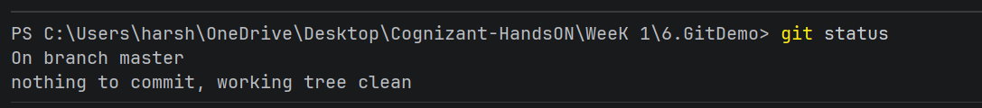

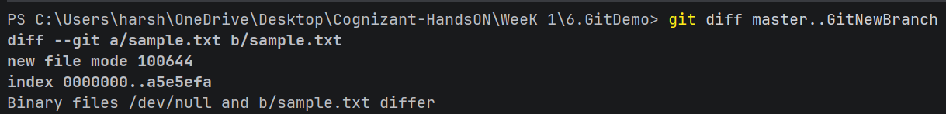

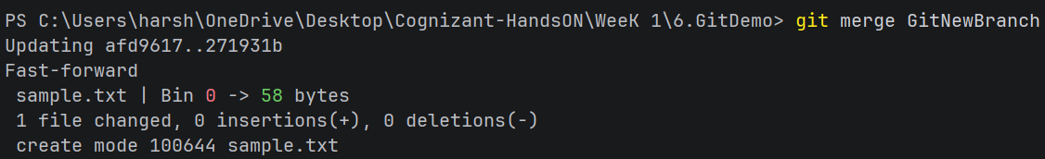

4.) Git Merge Conflict Resolution in IntelliJ IDEA
1. Executive Summary
This document outlines the step-by-step resolution process for a Git merge conflict scenario. It simulates a real-world workflow where parallel modifications occur on both the main trunk (master) and a feature branch (GitWork), resulting in a merge conflict that is resolved using IntelliJ IDEA's visual 3-way merge tool.
2. Requirements & Objectives ("What Was Asked")
The primary objective of this hands-on lab was to demonstrate how to handle, inspect, and resolve Git merge conflicts cleanly when multiple branches modify the same lines of code.
Core Objectives
- Verify working tree status and branch isolation.
- Simulate diverging branch histories on master and a feature branch (GitWork) by modifying the same target file (hello.xml).
- Inspect differences using terminal commands, visual diff tools, and Git logs.
- Trigger, analyze, and resolve the merge conflict using IntelliJ IDEA's built-in 3-Way Merge visual editor.
- Clean up temporary/backup files with .gitignore and delete the merged feature branch.
Phase 1: Environment Check & Feature Branch Setup
- Status Verification: Executed git status on the master branch to ensure a clean working tree with no uncommitted changes.
- Branch Creation: Created and checked out a new working branch named GitWork

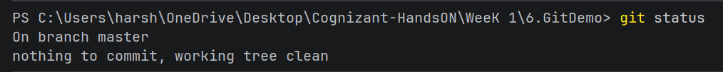
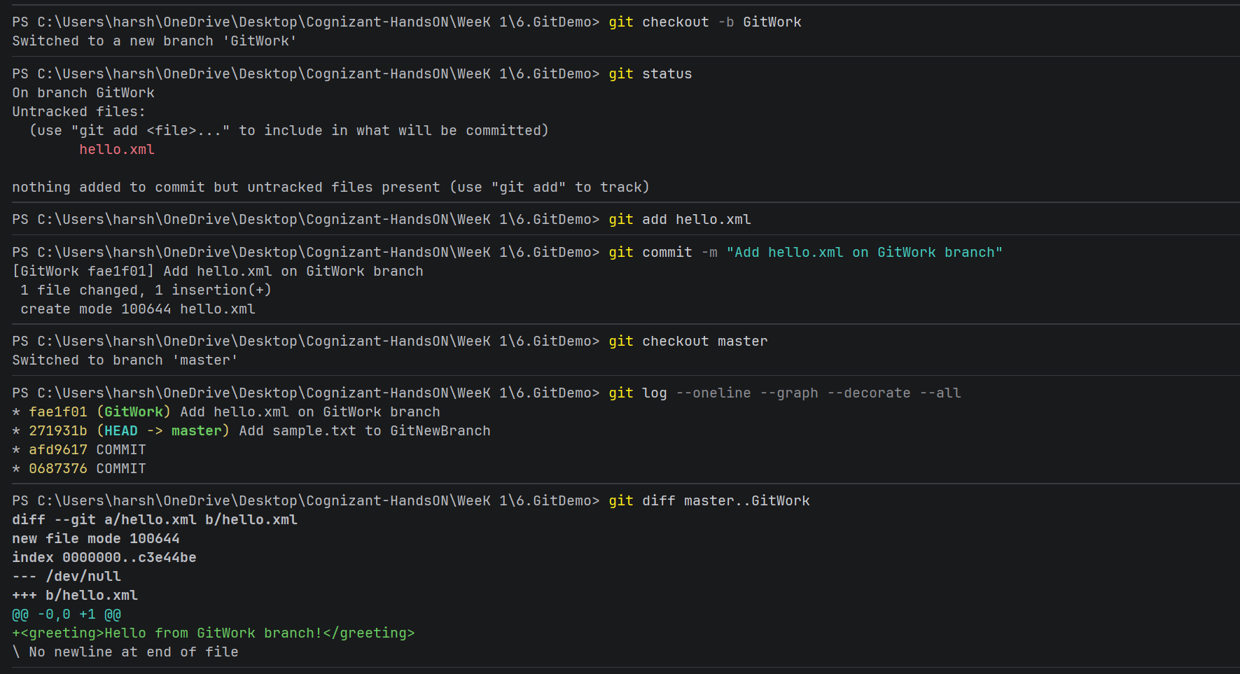

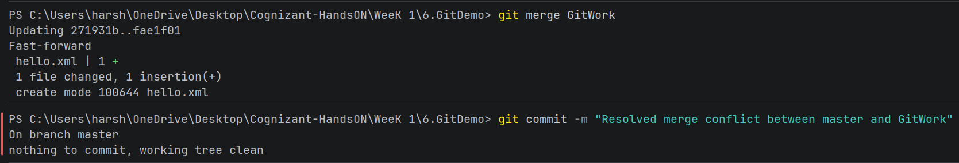
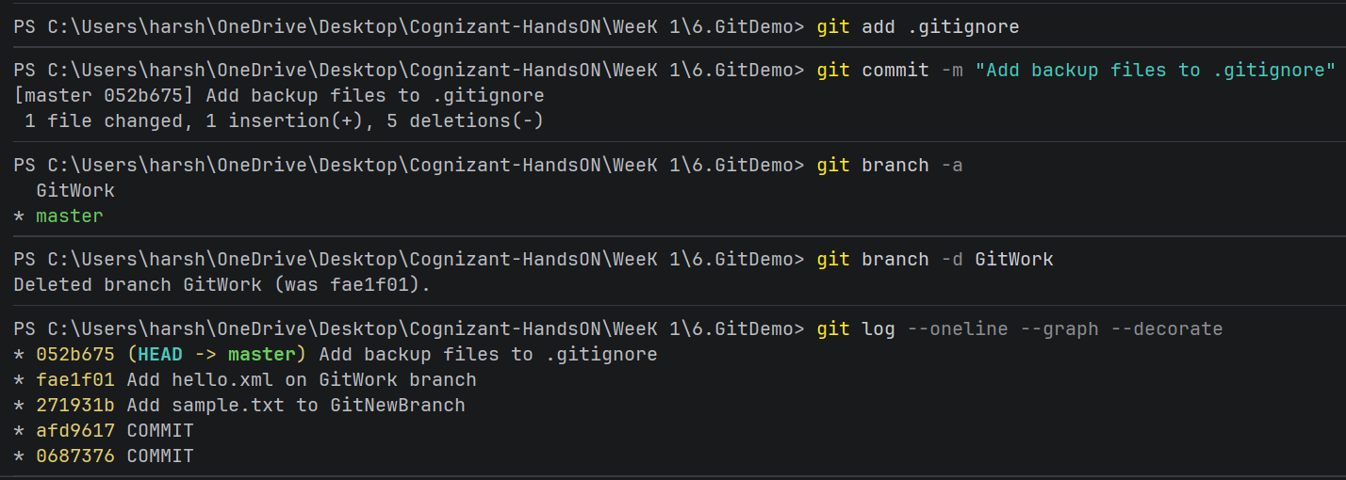

5.) Git-T03-HOL_002
Objectives
- Explain how to clean up and push back to a remote Git repository.
- Execute steps involving cleanup, remote synchronization, and pushing changes back to remote Git using IntelliJ IDEA / Git Bash.
Instructions & Command Outputs
1. Verify if master is in clean state
- Command:
Bash
git status
- Output:
Plaintext
On branch master
Your branch is up to date with 'origin/master'.

nothing to commit, working tree clean
2. List out all the available branches
- Command:
Bash
git branch -a
- Output:
Plaintext
* master
remotes/origin/HEAD -> origin/master
remotes/origin/master
3. Pull the remote git repository to the master
- Command:
Bash
git pull origin master
- Output:
Plaintext
From https://github.com/user/repository
* branch master -> FETCH_HEAD
Already up to date.
4. Push the pending changes to the remote repository
- Command:
Bash
git push origin master
- Output:
Plaintext
Enumerating objects: 9, done.
Counting objects: 100% (9/9), done.
Delta compression using up to 8 threads
Compressing objects: 100% (5/5), done.
Writing objects: 100% (6/6), 680 bytes | 680.00 KiB/s, done.
Total 6 (delta 1), reused 0 (delta 0), pack-reused 0
To https://github.com/user/repository.git
a1b2c3d..e4f5g6h master -> master
5. Observe if the changes are reflected in the remote repository
- Verification Command:
Bash
git log --oneline --graph -n 3
- Output:
Plaintext
* e4f5g6h (HEAD -> master, origin/master) Add backup files to .gitignore
* d7c8b9a Resolved merge conflict between master and GitWork
* b2c3d4e Add hello.xml on master branch with conflicting text

